# **PLCC Financing Flow**

Log into XPOS

Add SKU: 10101070

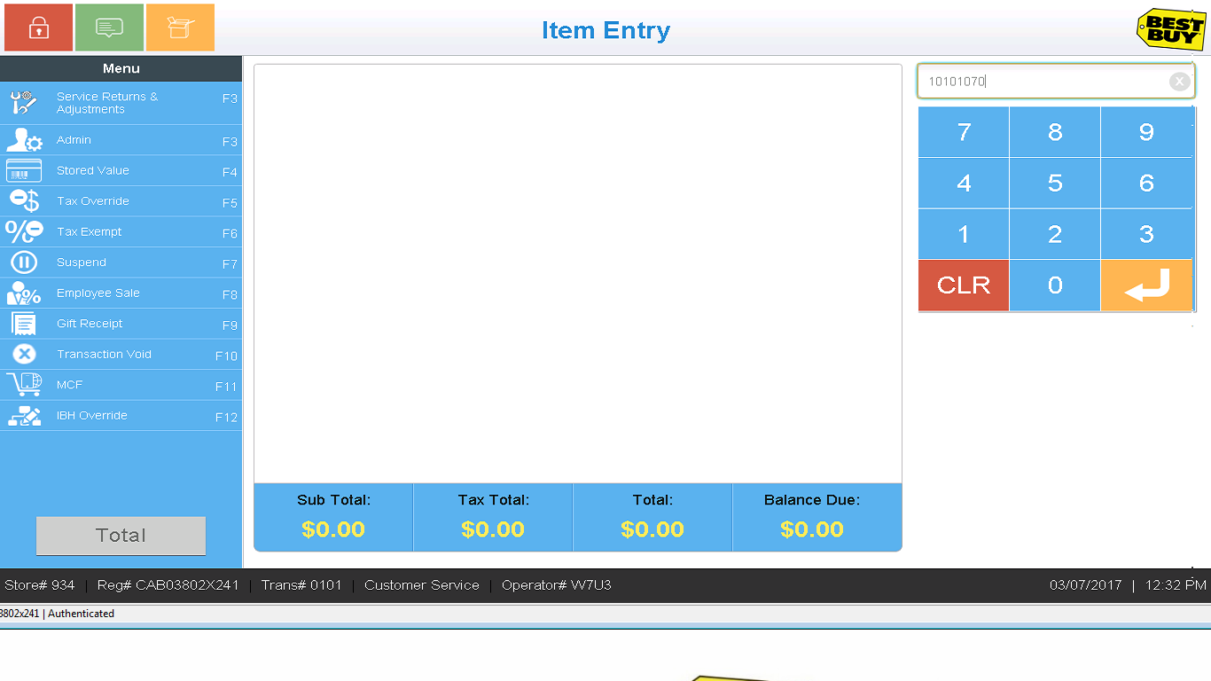

SKU added to transaction. Select Total.

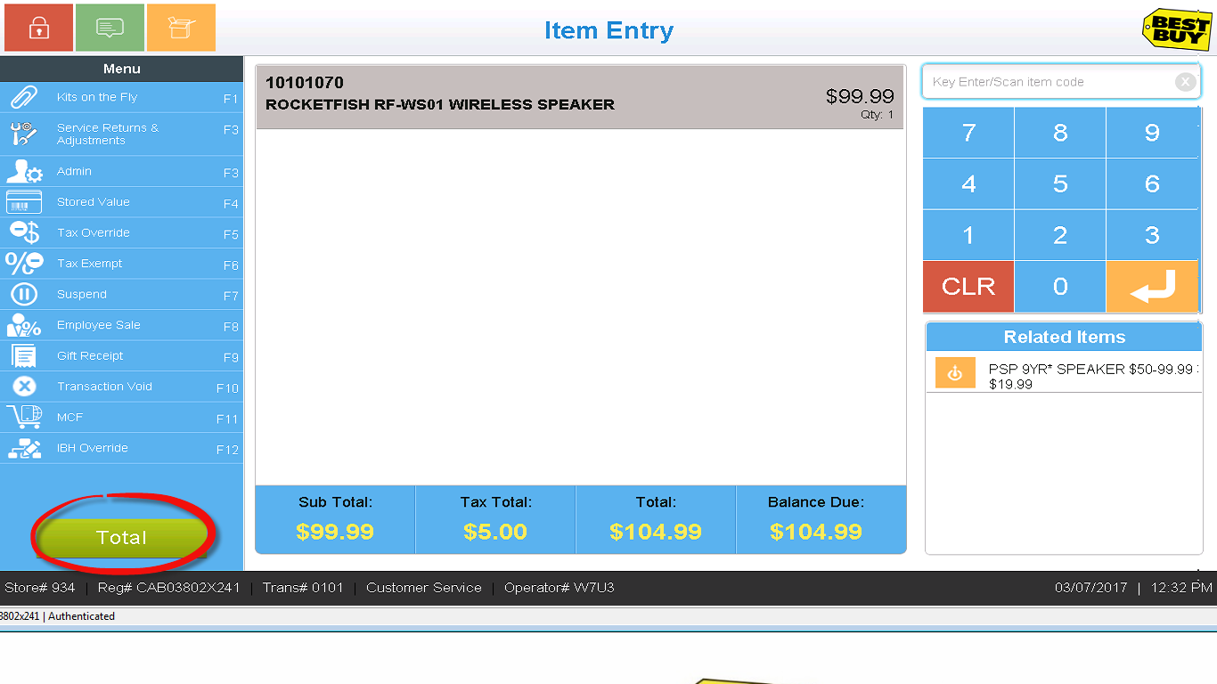

Enter tender amount and select Credit/Debit from the Tender Options menu on the left hand side.

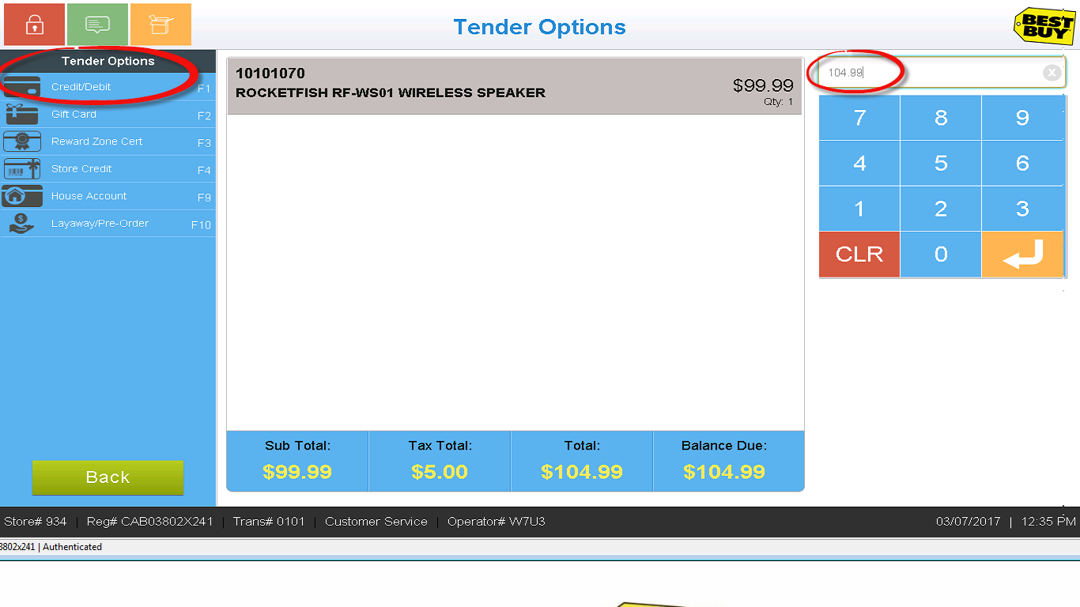

Select Credit/Debit from the pop-up window

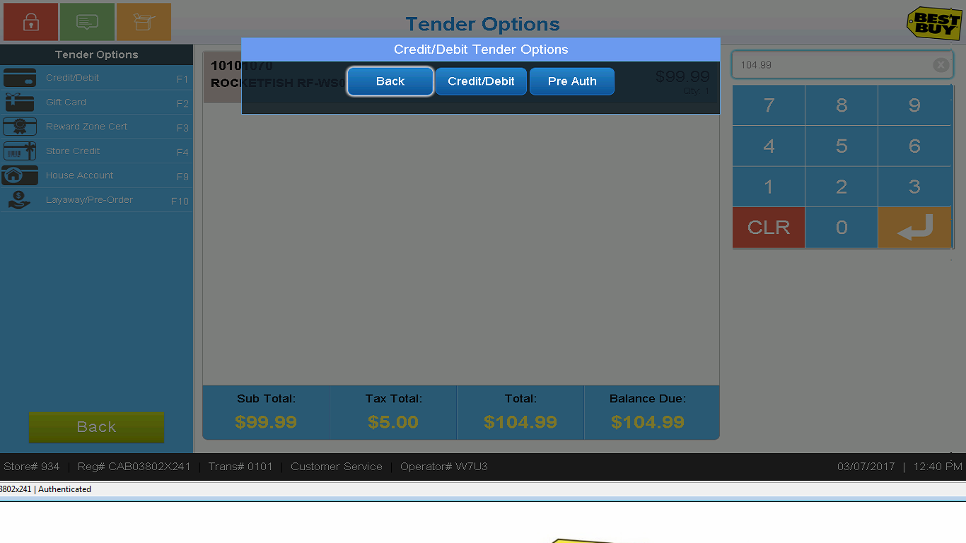

Swipe PLCC card on the signature pad

System displays a list of available finance plans on the right hand side along with back and continue buttons on the left hand side

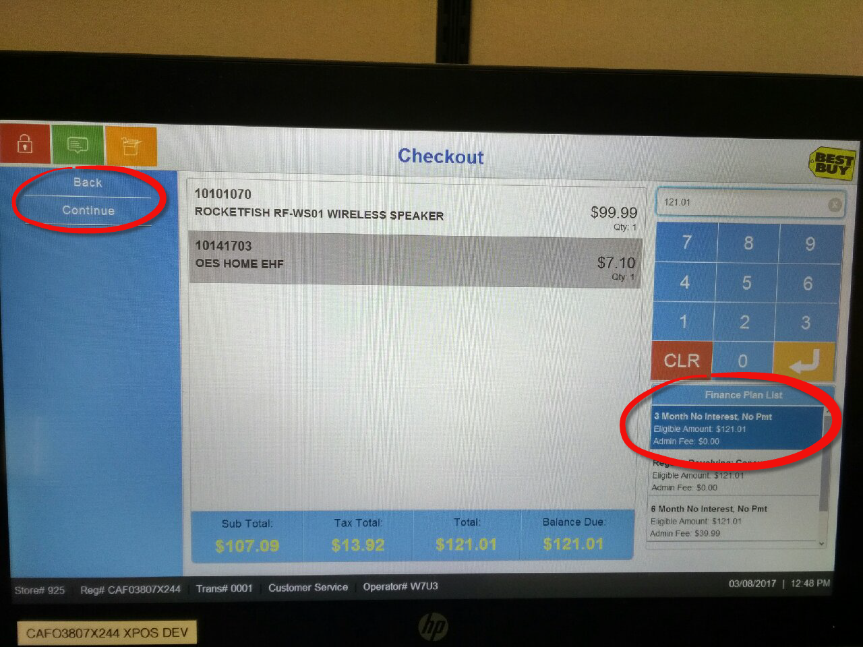

Select/highlight the plan of choice and click Continue. (If you click Back, the screen will return to the Tender Options screen.)

Enter the amount to finance and click Continue.

